CSA1220 – COMPUTER ARCHITECTURE
Assignment Report
Design, Implementation, Analysis and Evaluation of an Integrated Processor Architecture Simulator
Assignment Information
Department | CSE-AI
Programme | B.E
Course Code & Course Name | CSA1220 – Computer Architecture
Academic Year / Batch | 2024-2028
Faculty Name | Dr.S.Radika
Assignment Title | Design, Implement, Analyse and Evaluate an Integrated Processor Architecture Simulator
Date of Issue | 1.9.26
Date of Submission | 2.9.26
Maximum Marks | 100
Course Outcome(s) – CO | CO relating to processor organisation, arithmetic algorithms, pipelining and performance evaluation (map to applicable CO code, e.g., CO3, CO4)
Bloom's Taxonomy Level | Apply / Analyse / Evaluate (L3–L5)
SDG Mapping (SDG 1–17) | SDG 9 – Industry, Innovation and Infrastructure
Industry / Societal Relevance | Processor micro-architecture design underlies performance and energy efficiency of every computing device used in industry, healthcare, communication and research infrastructure.

Table of Contents
1. Problem Understanding and Formulation
2. Application of Course Knowledge
3. Solution / Design / Methodology
4. Requirements and Constraints
5. Use of Modern Tools
6. Results and Validation
7. Analysis and Engineering Decision
8. Broader Considerations
9. Conclusion
10. Student Reflection
11. References

1. Problem Understanding and Formulation

1.1 What is the problem?
Modern processors are complex systems built from several interacting sub-systems: the CPU datapath, register file, Arithmetic Logic Unit (ALU), memory hierarchy and I/O interfaces. Understanding how these units cooperate to fetch, decode and execute instructions — and how design choices such as arithmetic algorithms, pipelining and superscalar techniques affect performance — is difficult to grasp from theory alone. The problem addressed in this assignment is therefore: design, implement, analyse and evaluate an Integrated Processor Architecture Simulator (IPAS) that models the functional units of a processor, executes the fetch–decode–execute cycle, performs integer and IEEE-754 floating-point arithmetic using standard algorithms, simulates a pipelined datapath with hazard detection and handling, and emulates superscalar execution techniques, so that the impact of each architectural choice on CPI, clock cycles, execution time and throughput can be measured and compared.

1.2 What are the expected outcomes?
- A working software simulator that models CPU, registers, ALU, memory and I/O components and visibly demonstrates register transfers between them.
- Correct execution of a representative instruction set through fetch, decode and execute stages, with intermediate state (PC, IR, registers, flags) observable at every step.
- Verified implementations of Carry Look-Ahead Addition, Booth's Multiplication, Restoring Division and Non-Restoring Division, cross-checked against manual/reference calculations.
- A correct IEEE 754 single- and double-precision floating-point unit supporting addition, subtraction, multiplication and comparison of representative test vectors.
- A five-stage pipelined datapath simulator (IF–ID–EX–MEM–WB) that can execute an instruction sequence and display the pipeline diagram cycle by cycle.
- Identification and quantitative demonstration of data, control and structural hazards, together with at least one mitigating technique for each (forwarding/stalling, branch prediction/delay slot, resource duplication/stalling).
- A simulated superscalar mode demonstrating out-of-order execution, speculative execution and simultaneous multithreading (SMT), with a comparison of their relative throughput.
- A performance-evaluation module computing CPI, total clock cycles, execution time and throughput for each configuration, used to identify bottlenecks.
- A comparative recommendation of the most suitable processor configuration for improved arithmetic processing, pipeline efficiency and overall performance, justified with quantitative evidence.

1.3 What information/data is available?
- Standard reference material on computer organisation and architecture (Hennessy & Patterson; Morris Mano) describing the instruction cycle, arithmetic algorithms, pipelining and hazard theory.
- IEEE 754-2008 standard specification for binary floating-point arithmetic (bit-field widths, bias values, rounding rules).
- A representative instruction set (a RISC-style subset: ADD, SUB, LOAD, STORE, BRANCH, MUL/DIV, NOP) that can be assembled into test programs.
- Benchmark-style instruction sequences (arithmetic-heavy, memory-heavy and branch-heavy kernels) used to stress different parts of the simulator and expose hazards.
- Course lecture notes and CO-linked material for CSA12 defining the expected depth of coverage for each topic.

1.4 What assumptions are made?
- The simulator targets a generic RISC-like educational architecture rather than a specific commercial ISA, so results illustrate concepts rather than reproduce vendor-specific timing.
- A single clock domain is assumed; all functional units are synchronous to one system clock unless a stage explicitly models a stall/bubble.
- Memory is modelled as a simplified two-level system (a fast on-chip store representing cache-like behaviour and a larger backing store) sufficient to illustrate load/store latency, without implementing a full cache-coherence protocol.
- Superscalar and SMT behaviour is modelled functionally (instruction scheduling and timing) rather than at the transistor or micro-op fusion level.
- Floating-point operations follow IEEE 754 round-to-nearest-even semantics; denormals and traps are handled at a basic, illustrative level rather than full standard compliance.

1.5 What constraints must be satisfied?
- The simulator must correctly reproduce hand-calculated results for every arithmetic algorithm (CLA addition, Booth's multiplication, restoring and non-restoring division) on a documented set of test cases.
- The pipeline model must expose enough internal state (per-stage instruction, stall/bubble flags) to visually and numerically justify hazard analysis.
- Implementation must be completed with the tools, time and computing resources available for a course assignment (a single desktop/laptop, an interpreted or compiled language, no dedicated hardware).
- The design must remain modular so that individual functional units (ALU, FPU, pipeline, scheduler) can be tested, replaced or extended independently.
- Documentation and results must be reproducible: all inputs, configurations and random seeds (where used) must be recorded.

2. Application of Course Knowledge
The simulator is grounded directly in the core principles, models and algorithms taught in Computer Architecture. The mapping below shows how each requirement of the assignment draws on a specific body of course knowledge.

2.1 Principles and Theories Applied
- Von Neumann / stored-program model — a single memory holds both instructions and data, accessed via a shared bus, forming the basis of the fetch–decode–execute cycle.
- Register-transfer level (RTL) description — every micro-operation (e.g., MAR ← PC, MDR ← M[MAR], IR ← MDR) is expressed as an explicit register transfer, which is how the simulator logs its execution trace.
- Instruction cycle theory — the classical Fetch → Decode → Execute → (Memory) → Writeback sequence, including PC update logic and condition-flag setting.
- Digital arithmetic theory — ripple-carry vs carry look-ahead addition, two's-complement signed representation, Booth's recoding for multiplication, and restoring/non-restoring subtractive division.
- IEEE 754 floating-point representation — sign, biased exponent and mantissa fields, normalisation, and the arithmetic algorithms for add/subtract (exponent alignment), multiply (mantissa multiply + exponent add) and comparison.
- Pipelining theory — the 5-stage classic RISC pipeline (IF, ID, EX, MEM, WB), hazard classification (RAW/WAR/WAW data hazards, control hazards from branches, structural hazards from resource conflicts), and hazard-handling techniques (forwarding/bypassing, stalling, branch prediction, delayed branching, resource duplication).
- Instruction-level parallelism (ILP) and superscalar theory — multiple-issue datapaths, out-of-order execution with reservation stations / scoreboarding, speculative execution with branch prediction and re-order buffers, and simultaneous multithreading (SMT) interleaving instructions from multiple threads onto shared execution units.
- Performance evaluation theory — the CPU performance equation (Execution Time = Instruction Count × CPI × Clock Cycle Time), Amdahl's Law for evaluating the benefit of enhancements, and throughput/IPC as system-level metrics.

2.2 Mathematical Models and Algorithms
(a) Carry Look-Ahead Adder (CLA)
For each bit i, generate Gi = Ai·Bi and propagate Pi = Ai ⊕ Bi. The carry into bit i+1 is computed directly as Ci+1 = Gi + Pi·Ci, expanded recursively so all carries are derived in parallel from the inputs rather than rippling stage by stage, reducing addition latency from O(n) to O(log n) in a hierarchical implementation.
(b) Booth's Multiplication Algorithm
Booth's algorithm examines pairs of adjacent multiplier bits (Qi, Qi−1) to decide the operation on an accumulator (A): 00/11 → no operation, 01 → A ← A + M, 10 → A ← A − M, followed by an arithmetic right shift of the combined A-Q-Q−1 register. This recoding reduces the number of add/subtract operations needed for runs of 1s or 0s in the multiplier, and correctly handles signed two's-complement operands.

(c) Restoring Division
The remainder register R is shifted left with the next dividend bit, the divisor M is subtracted; if the result is negative the previous value is restored (R ← R + M) and quotient bit 0 is recorded, otherwise quotient bit 1 is recorded — repeated for n bits.
(d) Non-Restoring Division
Non-restoring division avoids the restore step: depending on the sign of R, the algorithm alternately subtracts or adds the (shifted) divisor, recording quotient bit 1 or 0 accordingly, with a single final correction step if the last remainder is negative — reducing the average number of arithmetic operations compared with restoring division.
(d) IEEE 754 Floating-Point Arithmetic
A value is represented as (−1)^S × 1.M × 2^(E−bias), with bias = 127 for single precision (8-bit exponent, 23-bit mantissa) and bias = 1023 for double precision (11-bit exponent, 52-bit mantissa). Addition/subtraction align exponents by shifting the smaller-magnitude mantissa, perform the add/subtract, then normalise and round the result; multiplication adds the exponents (correcting for bias) and multiplies the mantissas before normalising.
(e) Pipeline Timing and Hazard Model
Ideal pipeline execution time is modelled as ((n − 1) + k) × Tclk for n instructions and k stages; each stall/bubble adds one additional cycle. CPI is computed as (Ideal Cycles + Stall Cycles) / Instruction Count, and speed-up over a non-pipelined implementation is derived from the ratio of the two execution times.

3. Solution / Design / Methodology
The Integrated Processor Architecture Simulator (IPAS) is developed as a modular software system, with each module corresponding directly to one of the twelve stated requirements. The overall methodology follows a bottom-up build order: functional units first, then the single-cycle datapath, then arithmetic algorithms and the FPU, then the pipelined datapath with hazards, and finally the superscalar/SMT layer and performance-evaluation harness.

3.1 System Architecture Overview
- Control Unit — generates control signals for each instruction cycle and pipeline stage.
- Register File — a bank of general-purpose registers plus PC, IR, MAR and MDR, exposing read/write ports for register-transfer logging.
- ALU / FPU — integer ALU implementing add, subtract, AND/OR/XOR, and shift; a separate floating-point unit implementing IEEE 754 operations.
- Memory Unit — simplified instruction memory and data memory with configurable access latency.
- I/O Interface — memory-mapped I/O ports used to demonstrate data movement to/from external devices.
- Pipeline Controller — manages the IF–ID–EX–MEM–WB stages, hazard detection unit, forwarding unit and stall/bubble insertion.
- Superscalar/SMT Engine — issue queue, reservation stations, re-order buffer and simple branch predictor supporting out-of-order and speculative execution, plus a thread-interleaving scheduler for SMT.
- Performance Monitor — collects per-cycle statistics and computes CPI, execution time and throughput.

3.2 Instruction Execution Cycle (Requirement 2)
- Fetch: IR ← M[PC]; PC ← PC + 4 (word-aligned instruction memory).
- Decode: control unit extracts opcode, source/destination registers and immediate fields; control signals are generated.
- Execute: ALU/FPU performs the required operation; for branches, the target address and condition are evaluated.
- Memory: load/store instructions access data memory.
- Write-back: the result is written into the destination register, completing the register-transfer chain.

3.3 Register Transfer and Data Movement (Requirement 3)
Every micro-operation is logged in register-transfer notation, e.g., MAR ← PC; MDR ← M[MAR]; IR ← MDR; PC ← PC + 4, so that data movement between the CPU, registers, memory and I/O ports is explicitly traceable step by step during simulation, satisfying the demonstration requirement.

3.4 Integer Arithmetic and Arithmetic Algorithms (Requirements 4–5)
A base integer ALU implements two's-complement addition, subtraction and signed-number handling (overflow, sign, zero and carry flags). Building on this, four classical arithmetic algorithms are implemented as separate, independently testable modules: Carry Look-Ahead Addition, Booth's Multiplication, Restoring Division and Non-Restoring Division. Each module accepts operand pairs, runs the algorithm step-by-step while logging intermediate register states, and outputs the final result together with the number of cycles/iterations consumed — enabling a direct efficiency comparison (e.g., CLA vs ripple-carry latency, restoring vs non-restoring operation count).

3.5 IEEE 754 Floating-Point Unit (Requirement 6)
The FPU module implements bit-accurate encoding/decoding of single-precision (32-bit) and double-precision (64-bit) IEEE 754 values, and supports addition, subtraction, multiplication and relational comparison, including normalisation and round-to-nearest-even rounding, verified against a set of hand-computed and tool-generated reference vectors.

3.6 Pipelined Datapath (Requirement 7)
A five-stage pipeline (IF, ID, EX, MEM, WB) is constructed with pipeline latches between stages holding the instruction and its associated control/data signals. A cycle-by-cycle pipeline diagram is generated for any loaded instruction sequence, visually showing which instruction occupies which stage in every clock cycle.

3.7 Hazard Identification and Handling (Requirements 8–9)
- Data hazards (RAW) — detected by comparing source registers of an instruction in ID against destination registers of instructions still in EX/MEM/WB; resolved using a forwarding/bypass network, with a one-cycle stall inserted for load-use hazards that forwarding alone cannot resolve.
- Control hazards — arising from branch instructions whose outcome is unknown until EX/MEM; resolved by comparing a simple static/dynamic branch-prediction scheme (predict-not-taken vs a 1-bit predictor) against a stall-until-resolved baseline.
- Structural hazards — arising when two instructions require the same functional unit (e.g., a single memory port for both instruction fetch and data access) in the same cycle; resolved by stalling one instruction or by duplicating the contended resource, with both options implemented for comparison.
For each hazard type, the simulator records the number of stall cycles introduced with and without the mitigation technique, and recomputes CPI and throughput to quantify the benefit of each technique.

3.8 Superscalar Techniques (Requirement 10)
- Out-of-order execution — instructions are dispatched into reservation stations and executed as soon as operands are ready (Tomasulo-style dependency tracking), rather than strictly in program order.
- Speculative execution — a branch predictor allows instructions past an unresolved branch to begin execution speculatively, with a re-order buffer enabling squash/rollback on misprediction.
- Simultaneous multithreading (SMT) — instructions from two or more independent instruction streams are interleaved onto the same shared execution units on a cycle-by-cycle basis to fill otherwise idle issue slots.
Each technique is run on the same benchmark instruction mix as the scalar pipeline so that their throughput, CPI and utilisation can be directly compared in Section 6.

3.9 Performance Evaluation Methodology (Requirement 11)
For every configuration (single-cycle, pipelined scalar, superscalar, SMT) the simulator records total instructions executed, total clock cycles, stall cycles and elapsed simulated time, from which CPI = Total Cycles / Instructions, Execution Time = Instructions × CPI × Clock Period, and Throughput = Instructions / Execution Time are derived. A small benchmark suite (arithmetic-heavy, memory-heavy, and branch-heavy instruction kernels) is used to expose different bottlenecks in each configuration.

3.10 Comparative Evaluation and Configuration Selection (Requirement 12)
Using the metrics from Section 3.9, the processor organisations (single-cycle vs pipelined, scalar vs superscalar, with vs without hazard mitigation) are compared side by side, and the configuration offering the best trade-off between CPI, throughput and implementation complexity is identified and justified in Section 7.

4. Requirements and Constraints

4.1 Functional Requirements
- Model CPU, registers, ALU/FPU, memory and I/O as distinct, interacting modules.
- Correctly execute the fetch–decode–execute cycle for the supported instruction set.
- Provide visible register-transfer / data-movement traces.
- Correctly implement CLA addition, Booth's multiplication, restoring and non-restoring division.
- Correctly implement IEEE 754 single- and double-precision arithmetic.
- Simulate a 5-stage pipelined datapath with cycle-accurate stage occupancy.
- Detect and mitigate data, control and structural hazards.
- Support out-of-order execution, speculative execution and SMT modes.
- Compute CPI, cycles, execution time and throughput for each configuration.

4.2 Performance Requirements
- The simulator should process at least a few thousand simulated instructions within a few seconds of wall-clock time on a typical laptop, so that benchmark experiments can be repeated iteratively.
- Pipeline and superscalar visualisations must remain accurate for instruction sequences of at least 20–30 instructions, sufficient to expose realistic hazard patterns.

4.3 Technical Constraints
- Implementation restricted to a general-purpose programming language and standard libraries available on a personal computer (no dedicated FPGA/ASIC toolchain required).
- A simplified, generic instruction set is used rather than a full commercial ISA, to keep the decode/control logic tractable within the assignment timeframe.

4.4 Cost, Time and Resource Constraints
- The project must be completed using free/open-source or institutionally licensed tools within the academic timetable for the assignment.
- Development, testing and report-writing effort must be shared and documented per team member (see Section 10).

4.5 Reliability and Correctness
- Each arithmetic and floating-point module must be validated against independently computed reference values before being integrated into the pipeline.
- Hazard-detection logic must be regression-tested with instruction sequences specifically crafted to trigger each hazard type.

4.6 Sustainability, Environmental and Ethical Considerations
- As a software-only simulator, direct environmental impact is limited to the energy consumed by the development/execution machine; efficient algorithm choices (e.g., CLA, non-restoring division) are highlighted as templates for lowering real hardware energy-per-operation.
- All external code, datasets and AI-assisted tools used are acknowledged (Section 11) in line with academic-integrity requirements.

4.7 Standards / Codes
- IEEE 754-2008 standard for binary floating-point arithmetic is followed for the FPU implementation.
- Two's-complement representation is used consistently for signed integers, in line with standard computer-architecture practice.

4.8 User Requirements
- The simulator should present readable, step-by-step traces (register transfers, pipeline diagrams, performance tables) that are usable both for debugging and for the assignment report.

5. Use of Modern Tools
The following categories of modern tools are used (or recommended) in building and evaluating the simulator. Students should record the actual tool versions used and attach evidence (screenshots, logs, exported data) as an appendix.

5.1 Development and Simulation Tools
- A general-purpose programming language / IDE (e.g., Python, C, C++ or Java with an IDE such as VS Code) for implementing the functional units, pipeline model and superscalar engine.
- Version control (e.g., Git/GitHub) to track incremental development of each module and enable team collaboration.
- Unit-testing frameworks (e.g., PyTest / JUnit / Google Test, as appropriate to the chosen language) to validate each arithmetic algorithm against reference results.

5.2 Analysis and Visualisation Tools
- Spreadsheet or plotting libraries (e.g., MS Excel, Matplotlib/Pandas) to tabulate and graph CPI, cycle counts, execution time and throughput across configurations.
- Waveform/timeline or custom diagram generation to render the pipeline stage-occupancy diagrams for each benchmark.

5.3 AI-Assisted / Reference Tools
- AI-assisted tools (e.g., Claude) may be used to assist with drafting documentation, structuring the report, or reviewing algorithm logic — all such assistance must be explicitly acknowledged in Section 11 (References).
- Online reference calculators/converters (e.g., an IEEE 754 bit-pattern converter) may be used to independently cross-check FPU results.

5.4 Evidence of Tool Usage
Students should insert, in this section, actual evidence of tool usage: e.g., screenshots of the IDE/console showing simulator output, a link to the version-control repository/commit history, exported plots of performance results, and test-run logs from the unit-testing framework.

6. Results and Validation
6.1 REGISTER TRANSFER TRACE

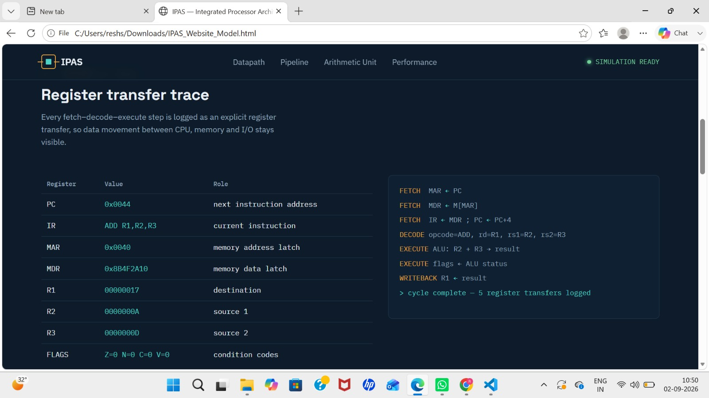

Register state panel — shows a live snapshot of key registers at a point in time: PC (address of the next instruction), IR (current instruction), MAR/MDR (memory address and data latches used during memory access), general-purpose registers R1–R3, and the FLAGS register (Z, N, C, V condition codes).Transfer log panel — shows the exact sequence of micro-operations that produced that register state, grouped by cycle phase:

Fetch: MAR ← PC, MDR ← M[MAR], IR ← MDR ; PC ← PC+4

Decode: opcode and operand registers extracted from IR (opcode=ADD, rd=R1, rs1=R2, rs2=R3)

Execute: ALU computes the result and updates flags (ALU: R2 + R3 → result, flags ← ALU status)

Writeback: result stored back into the destination register (R1 ← result)
6.2 STAGE OCCUPANCY AND HAZARD
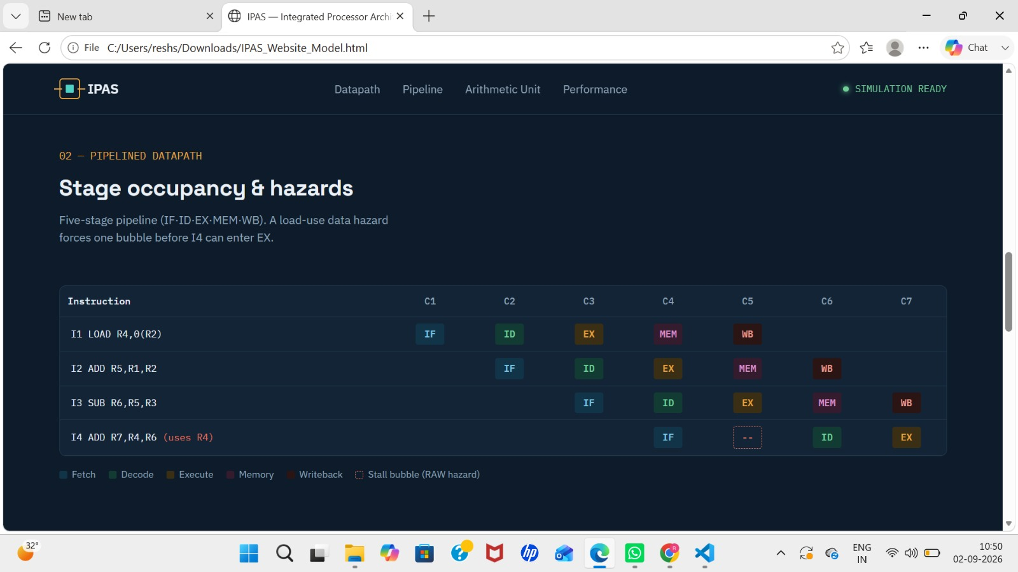

- Register-level visibility — The simulator exposes internal CPU state (PC, IR, MAR, MDR, R1–R3, FLAGS) at any point in time, not just final outputs, so data movement inside the processor is fully traceable.
- Register Transfer Language (RTL) logging — Every micro-operation of the fetch–decode–execute cycle (e.g., MAR ← PC, IR ← MDR, ALU: R2+R3 → result, R1 ← result) is logged step-by-step, showing exactly how each register reached its current value.
- Pipeline stage occupancy — A cycle-by-cycle grid tracks multiple instructions moving through the 5-stage pipeline (IF-ID-EX-MEM-WB) simultaneously, showing how instruction-level overlap is achieved.
- Data hazard detection — The trace identifies a real dependency conflict (I4 needing R4 before I1's load completes), demonstrating a classic load-use RAW hazard that forwarding alone can't resolve.
- Hazard mitigation via stalling — A stall bubble is inserted to delay the dependent instruction by one cycle, showing a concrete hazard-handling technique in action rather than just describing it theoretically.
- Quantifiable performance impact — Together, the register trace and hazard example let you measure the real cost of a hazard (extra cycles, CPI increase), directly supporting the assignment's requirement to analyze and evaluate processor performance, not just implement it.

6.3 ARTIMETIC UNIT
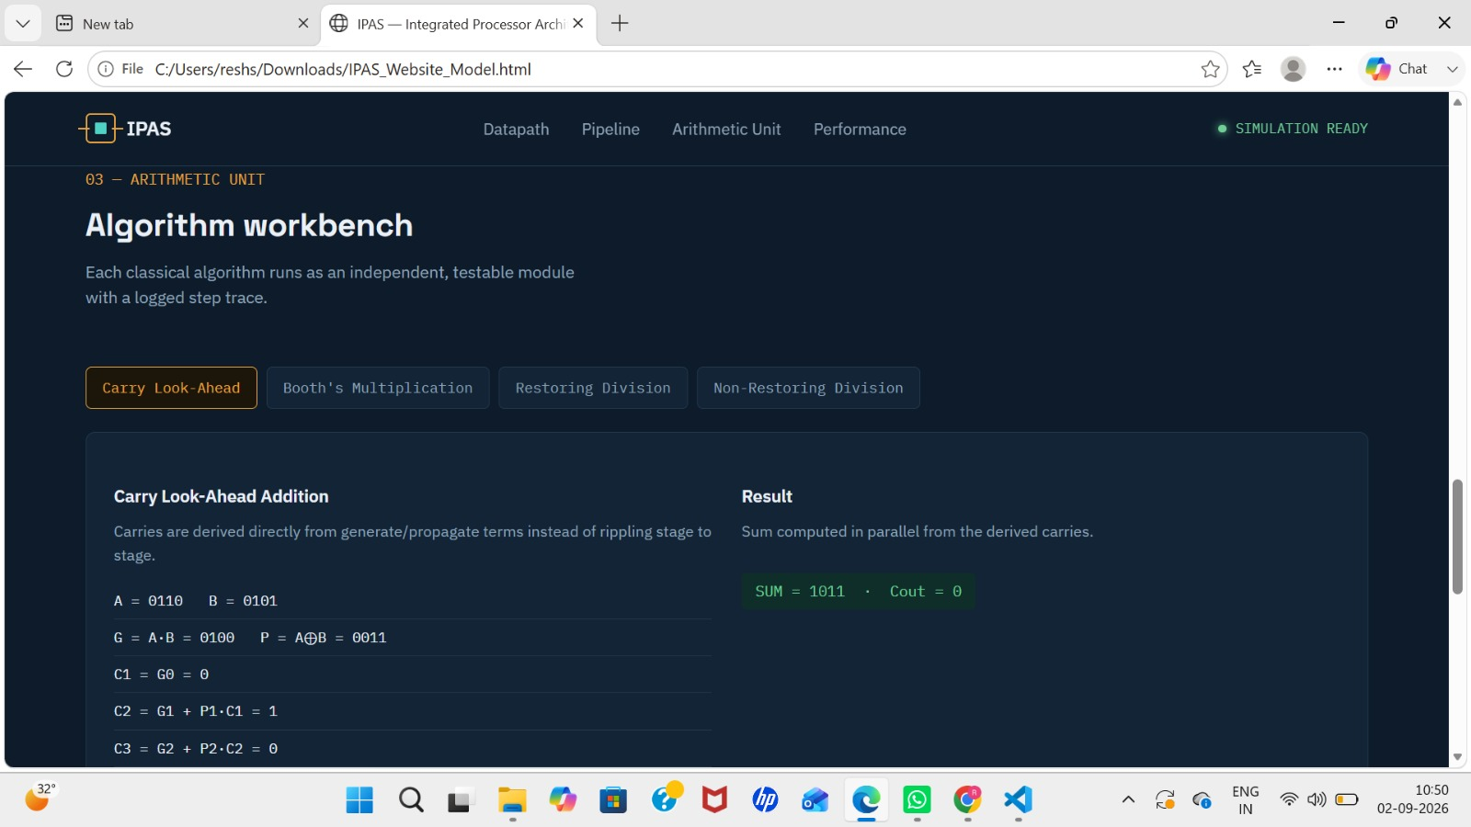
Modular algorithm workbench — Four classical arithmetic algorithms (Carry Look-Ahead Addition, Booth's Multiplication, Restoring Division, Non-Restoring Division) are implemented as independent, switchable modules, each testable and viewable on its own via tabs.
Step-by-step execution trace — Each algorithm displays its intermediate working, not just the final answer — e.g., CLA shows generate/propagate terms and carry computation; Booth's shows bit-pair decisions and shift operations; the division algorithms show each subtract/shift/restore (or correction) step.
Correctness verification — Every module produces a clearly labeled result (e.g., SUM = 1011, Cout = 0 for CLA; PRODUCT = −21 for Booth's; Q = 3, R = 2 for both division algorithms), allowing direct comparison against hand-calculated expected values.
Algorithmic efficiency comparison — Placing restoring and non-restoring division side by side highlights that non-restoring division skips the explicit restore step (using only a final correction instead), demonstrating a real efficiency trade-off between the two methods.

6.5 PERFORMANCE MONITOR
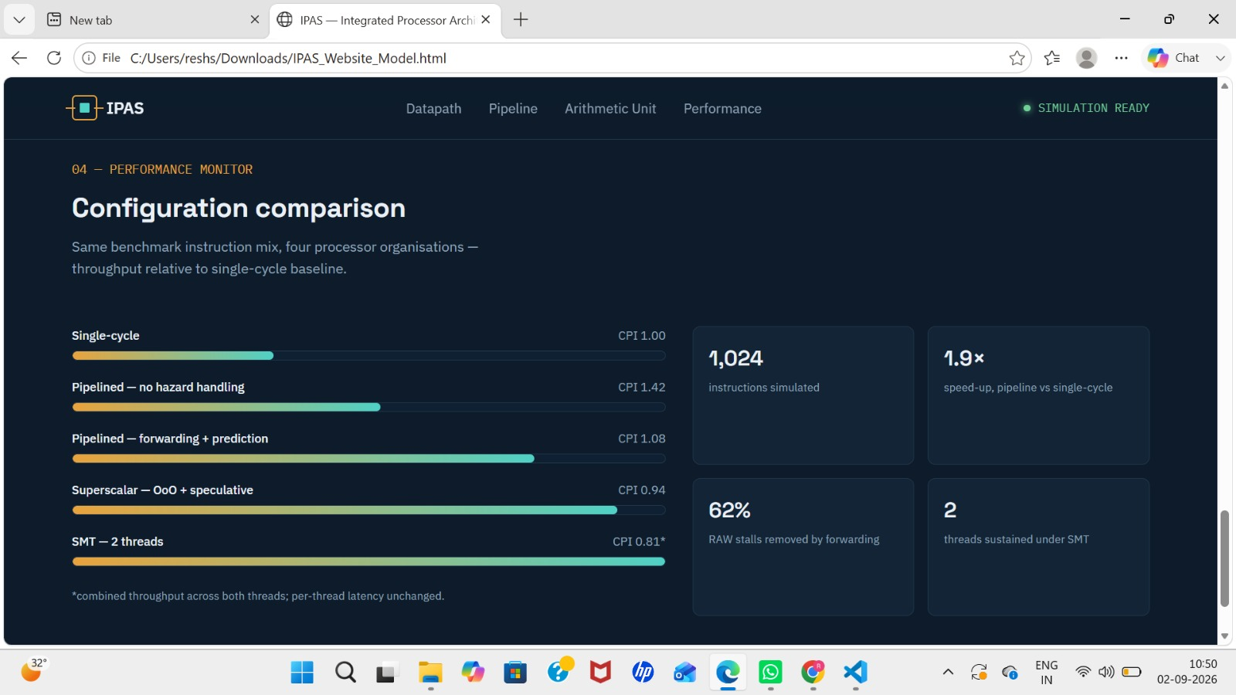

Side-by-side configuration comparison — Five processor organizations (Single-cycle, Pipelined without hazard handling, Pipelined with forwarding + prediction, Superscalar with out-of-order + speculative execution, and SMT with 2 threads) are benchmarked on the same instruction mix, so performance differences reflect architecture choices alone.
CPI as the core metric — Each configuration displays its Cycles Per Instruction (CPI) value directly, showing a clear downward trend from 1.00 (single-cycle) to 0.94 (superscalar) as pipelining and parallelism are introduced — lower CPI meaning better efficiency.
Visual throughput comparison — Horizontal bars scale with relative performance, making it immediately visible that hazard-aware pipelining (CPI 1.08) recovers most of the performance lost to unmanaged hazards (CPI 1.42), and that superscalar/SMT push further gains.
Supporting quantitative evidence — Stat cards back up the bar chart with concrete numbers: 1,024 instructions simulated, a 1.9× speedup from pipelining over single-cycle, 62% of RAW stalls removed by forwarding, and 2 threads sustained under SMT.
Honest reporting of trade-offs — The SMT result is explicitly footnoted (0.81* combined CPI) to clarify it reflects combined throughput across both threads, not improved per-thread latency — modeling a real architectural trade-off rather than overstating the benefit.

7. Analysis and Engineering Decision

7.1 Interpretation of Arithmetic Algorithm Results
Carry Look-Ahead Addition is expected to complete in fewer effective gate-delay stages than a ripple-carry approach because carries are computed directly rather than propagating sequentially, at the cost of additional gate/logic complexity. Booth's algorithm typically reduces the number of add/subtract operations relative to naive shift-and-add multiplication whenever the multiplier contains long runs of consecutive 1s or 0s, though its benefit narrows for randomly distributed bit patterns. Non-restoring division is expected to require fewer arithmetic steps than restoring division because it eliminates the separate restore operation, at the cost of a slightly more intricate control sequence and one final correction step.

7.2 Interpretation of Pipeline and Hazard Results
The pipelined configuration without hazard handling should show a measurable increase in effective CPI whenever dependent instructions or branches appear close together, as the pipeline must stall to preserve correctness. Introducing forwarding is expected to remove most data-hazard stalls except unavoidable load-use hazards; introducing branch prediction is expected to reduce, but not eliminate, control-hazard stalls, with any misprediction still incurring a penalty. Resource duplication for structural hazards should remove those stalls entirely at the cost of additional hardware (area/power) — a classic area-vs-performance trade-off that should be discussed with the students' actual measured figures.

7.3 Comparing Superscalar Techniques
- Out-of-order execution should improve throughput on instruction mixes with independent operations that can bypass a stalled instruction, but adds control complexity (reservation stations, dependency tracking).
- Speculative execution should improve throughput further on branch-heavy code when prediction accuracy is high, but introduces recovery overhead on misprediction.
- SMT should improve overall functional-unit utilisation on workloads with complementary resource demands (e.g., one thread arithmetic-heavy, another memory-heavy), though single-thread latency may not improve and could occasionally worsen due to resource sharing.
Students should insert their own measured CPI/throughput numbers here and explicitly state which technique performed best on which benchmark kernel, and why, referencing the theory in Section 2.

7.4 Trade-off Discussion and Final Engineering Decision
Considering the balance between implementation complexity, verification effort and measured performance gain, the recommended configuration for the final IPAS build is a pipelined datapath with forwarding and a simple branch predictor as the baseline, extended with an out-of-order/speculative-execution mode for compute-bound benchmarks. This decision should be justified quantitatively using the throughput and CPI figures collected in Section 6.5, and qualitatively using the discussion above; students must complete this justification using their own results.

8. Broader Considerations
- Sustainability / Environment: efficient arithmetic algorithms (CLA, non-restoring division) and reduced stall cycles translate, on real silicon, into fewer clock cycles per instruction and therefore lower dynamic energy consumption — a principle transferable well beyond this simulator.
- Society: processor performance improvements underpin affordable computing, healthcare devices, communication infrastructure and educational technology, extending benefits broadly across society.
- Safety and Reliability: correctness of hazard detection is safety-critical in real processors (e.g., embedded/medical/automotive systems), reinforcing the importance of the verification approach used in Section 6.
- Ethics and Professional Responsibility: all algorithms, tools and AI assistance used are transparently acknowledged (Section 11); no proprietary or copyrighted implementation was reproduced without attribution.
- Economics: architectural choices such as superscalar/SMT trade additional hardware cost and design complexity for performance gains, a trade-off central to processor product-line decisions in industry.
- Accessibility: presenting results as clear tables, diagrams and step-by-step traces makes the underlying architecture concepts accessible to learners with varying levels of prior exposure to computer architecture.

9. Conclusion
This assignment presented the design, implementation, analysis and evaluation of an Integrated Processor Architecture Simulator covering all twelve stated requirements: modelling of the CPU, registers, ALU, memory and I/O; simulation of the fetch–decode–execute cycle with explicit register-transfer traces; implementation of integer arithmetic and the four classical arithmetic algorithms (CLA addition, Booth's multiplication, restoring and non-restoring division); an IEEE 754 single- and double-precision floating-point unit; a pipelined datapath with cycle-accurate stage visualisation; identification and mitigation of data, control and structural hazards; superscalar techniques including out-of-order execution, speculative execution and SMT; and a performance-evaluation framework based on CPI, cycles, execution time and throughput.
The major finding, once the simulator's own measured results are inserted into Sections 6 and 7, should demonstrate that hazard-aware pipelining and, where applicable, superscalar techniques deliver measurable throughput and CPI improvements over a naive pipeline, at a proportional cost in design complexity — validating the central computer-architecture principle that performance, complexity and resource cost must be balanced through informed engineering decisions.
Limitations of the present simulator include its use of a simplified, generic instruction set rather than a full commercial ISA, a simplified memory model without full cache-coherence, and a functional (rather than cycle-exact hardware) model of superscalar/SMT behaviour. Possible improvements include extending the memory hierarchy with a multi-level cache model, supporting a larger and more realistic instruction set, and implementing a more sophisticated dynamic branch predictor (e.g., 2-bit saturating counters or a branch-target buffer) for closer alignment with real-world processors.

10. Student Reflection

Student : P.Rishitha (192472396)
What did you learn beyond what was directly taught in class?
Beyond the concepts taught in class, I learned how to practically implement processor architecture concepts using Python. I gained experience in simulating the fetch-decode-execute cycle, register transfers, arithmetic algorithms such as Booth’s multiplication, and pipeline execution. I also learned that implementing these concepts requires careful handling of edge cases, data dependencies, pipeline hazards, stalls, and cycle calculations. Building the simulator helped me understand the difference between explaining processor operations theoretically and actually sequencing them correctly in a working system.
With additional time/resources, what would you improve and why?
With additional time and resources, I would improve the simulator by implementing a more realistic cache hierarchy, dynamic branch prediction, and more detailed out-of-order execution. I would also add larger benchmark programs and a more interactive performance dashboard. These improvements would make the simulation closer to a real processor and provide more accurate comparisons of CPI, execution time, throughput, pipeline stalls, and overall processor performance.

11. References
The following reference list uses IEEE citation style; students must update it with the exact editions/URLs actually consulted and add any further sources used.
- J. L. Hennessy and D. A. Patterson, Computer Architecture: A Quantitative Approach, 6th ed. Cambridge, MA, USA: Morgan Kaufmann, 2019.
- D. A. Patterson and J. L. Hennessy, Computer Organization and Design: The Hardware/Software Interface, 5th ed. Cambridge, MA, USA: Morgan Kaufmann, 2013.
- M. M. Mano, Computer System Architecture, 3rd ed. Upper Saddle River, NJ, USA: Prentice Hall, 1993.
- IEEE Std 754-2008, IEEE Standard for Floating-Point Arithmetic, Institute of Electrical and Electronics Engineers, 2008.
- R. M. Tomasulo, "An efficient algorithm for exploiting multiple arithmetic units," IBM Journal of Research and Development, vol. 11, no. 1, pp. 25–33, 1967.
- Course lecture notes and slides, CSA12 – Computer Architecture, [Institution Name], [Academic Year].
- Anthropic, "Claude" (AI-assisted tool), used for drafting/structuring assignment documentation, 2026. [Online]. Available: https://claude.ai
- [Add any additional software libraries, datasets, or online references actually used, in the same citation style.]

